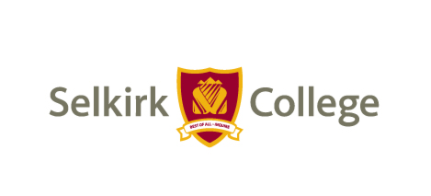**COVID-19 Working Group for Continuity and Recovery**

**Education Programming, Teaching & Learning**

**Terms of Reference**

**Purpose:** The Education Programming, Teaching & Learning Continuity and Recovery Working Group will be responsible for planning and implementing the recovery and continuity of educational programs, and the teaching and learning mandate of Selkirk College during the COVID-19 pandemic.

**Team**

* Deans and Chairs Committee
* Teaching & Learning Institute
* Health & Safety Advisor
* Subject matter experts

**Scope of Responsibilities**

Providing leadership in collaborative, creative, effective COVID-19 continuity and recovery planning, specifically:

1. Implementation of Safe Working Procedures (SWP) for the Education Division that follow the directives and recommendations from the Public Health Officer, WorkSafeBC and the Ministry of Advanced Education, Skills & Training;
2. Supporting the *COVID-19 Return to Campus Guidelines* that inform day to day operations and expectations; including students, employees and supervisors, community partners at campus, facilities and learning centres;
3. Development of plans and strategies that will guide the recovery of the areas of operation listed;
4. Providing leadership to the College by researching, adapting, and implementing best practices for recovery during and following the pandemic.

**Specific Output**

* Implementation of Safe Working Procedures and service delivery specifics in the areas related to programs and courses, teaching and learning support for instructors, program quality assurance, student learning experiences.
* Supporting and informing *COVID-19 Return to Campus Guidelines* for those areas listed;
* COVID-19 continuity and recovery plans for the areas listed including medium and long-term strategies for recovery of functional areas listed.

-30-