Visual Guidelines to Support the Promotion of Student-Led Initiatives

PREPARED: OCTOBER 2024

Selkirk College supports a variety of student-led clubs, events and activities that enhance the educational experience by fostering community, leadership and collaboration among students. These student-led initiatives serve as platforms for students to explore interests, develop skills and engage in extracurricular activities beyond their academic pursuits.
The Marketing & Communications Department (MarComm) plays a critical role in maintaining the integrity and consistency of Selkirk College's brand. This includes overseeing the use of corporate branding across all channels and ensuring that the college's identity is represented accurately and professionally.
This brief outlines the way in which MarComm will support student-led initiatives through the development of templates and process documentation while ensuring that brand identities are maintained.

To support brand stewardship, student-led initiatives are not permitted to use Selkirk College’s corporate branding in their promotional materials, including logos, taglines and official colors. This is to:
- Ensure brand consistency and make it possible to identify what are college-led and student-led events and activities.
- Prevent misrepresentation; the unregulated use of branding could lead to misinterpretation of the college’s endorsement of specific activities or events.

FRAMEWORK
Once the student-led initiative has been passed, please work with the students and the Marketing & Communication team to ensure that the promotion of the student-led initiative is completed in accordance with this brief. The students are permitted to design their own collateral to promote their initiative as long as the content and photos/illustrations are considered appropriate and not offensive. Additionally, the MarComm team developed a badge that states the event, activity, club is a “Selkirk College Student Initiative” and requires that this be included on all promotional materials.
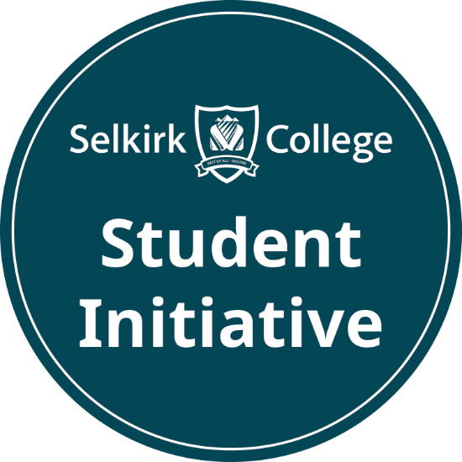

The MarComm team will support student-led initiatives by placing on the event calendar and ensuring exposure to these activities through the main College calendar: https://selkirk.ca/events and occasionally featured to Selkirk College’s main social media feeds.
Please work with the MarComm team to ensure that all activities featured on the event calendar on Selkirk.ca are kept up-to-date and relevant.

While Selkirk College encourages student-led initiatives, adherence to branding guidelines is essential for upholding the institution's image. The Marketing and Communications Department is available to provide guidance on alternative ways for clubs to promote their activities without infringing on corporate branding. Clubs are encouraged to create their own identities while aligning with the college’s values and mission.

