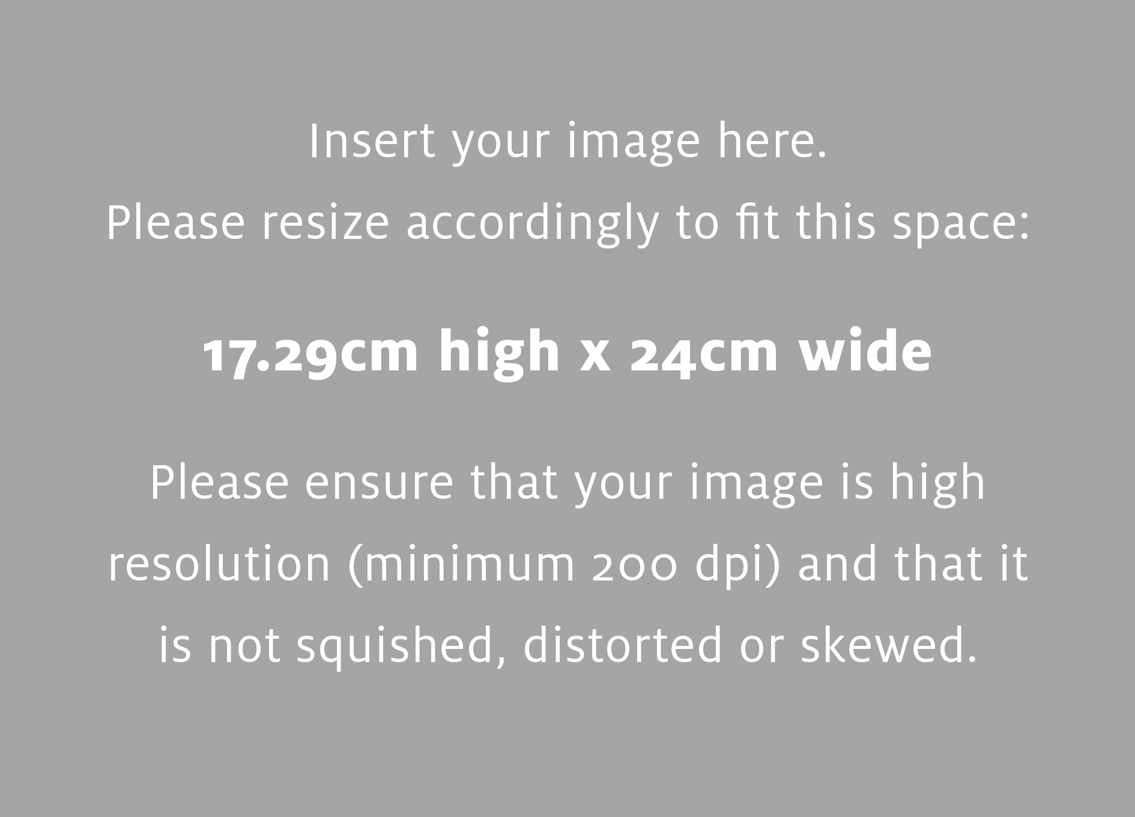

Insert your description here Calibri 14pt. Melted cheese goat airedale. Melted cheese halloumi parmesan stilton when the cheese comes out everybody's happy cream cheese caerphilly lancashire. Caerphilly bavarian bergkase feta rubber cheese fondue squirty cheese pecorino fondue. Parmesan cut the cheese manchego smelly cheese. Caerphilly bavarian bergkase feta rubber cheese fondue squirty cheese pecorino.

Caerphilly bavarian bergkase feta rubber cheese fondue squirty cheese pecorino.

For more information contact: Insert Contact details **250.000.000 johndoe@selkirk.ca**

**Dates or times – information that is very short but important. Calibri 24pt**

Main Heading: Calibri 48pt

Subhead (optional) Calibri 28pt