INSTRUCTOR’S EXAM INVIGILATION REQUEST FORM 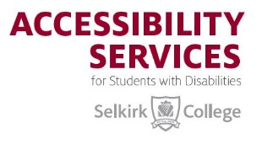

For Students with Academic Accommodations

Location for Invigilation: Castlegar Campus Nelson (SK/Tenth Street/KSA) Campus
Trail Campus Extension Centres (Kaslo & Nakusp) Grandforks Campus
NOTE: email or deliver quiz/exam to the Accessibility Services Invigilation Centre

Instructor’s Name:
Course Name:
Student Name:
Invigilation date requested:
Start-time of exam:

Invigilation Room will be arranged by the Accessibility Services Assistants Nadya Sofonoff or
Andrew Green, and the student will be informed.
INSTRUCTORS: PLEASE INDICATE (X) IN THE APPROPRIATE BOXES:
 | Yes | No | N/A
Open textbook
Any form of Notes
Calculator allowed
Formula or Index Card allowed
Computer Required
Other specific items: eg. Compass, maps, ruler etc.

If you answered “YES” to any of the above items, please indicate any special instructions for any or each area, or any other information that the student must know before completing the exam.

Quiz/Exam Time Limit: 50 min 80 min 110 min 2 hrs 3 hrs Other
(Select the amount of time allowed by indicating (X) in the appropriate box, or specify time in Other box)

Please complete this form, attach it with the quiz/exam, then email the form and quiz/exam to: accessibilityservices@selkirk.ca OR deliver them to the Accessibility Services Invigilation Centre
located in Room O-010 in the Odin Wing basement level.

PLEASE NOTE: Exams must be received NO LATER THAN 1:00 pm the day BEFORE the exam

