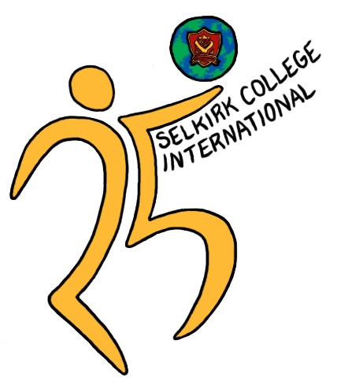

Selkirk International

25th Anniversary Reunion

July 8, 9 and 10, 2011 – Castlegar, B.C., Canada

|  |
| --- |
| PERSONAL PROFILE |

To celebrate 25 years of International Education at Selkirk College, we are collecting information about what past and present students, teachers, staff and friends are doing now. We have provided you with a ***‘Personal Profile’*** to complete.

**Name:**

Family Name:

First Name:

Nickname (if used):

Student, Teacher, Staff, Homestay Family, Other:

**If you used a different name at Selkirk College:**

Family Name:

First Name:

Nickname (if used):

**Contact information:**

Address:

Email:

Phone:

1. **Complete the Following Questions:**
   1. When were you a part of Selkirk college?  
        
      From:  
        
      To:  
        
      What did you study/do?
   2. What are you doing now?
   3. What is one of your fondest memories of Selkirk College?
   4. What is one thing you learned from your time at Selkirk College?
2. **Please write a message for the Anniversary.**
3. **Insert Photos of:**
   1. You at Selkirk College
   2. You and your friends at Selkirk College
   3. You now
   4. You and your life now (with friends, family or home, etc.)

***Thank you for completing these forms. Please email to:***

InternationalReunion@selkirk.ca

**If you have any questions, please don’t hesitate to contact us.**

**25th Anniversary Reunion Committee**

**🟋25th Anniversary Logo by Genevieve Bigué (2010-2011)**



Selkirk International

25th Anniversary Reunion

July 8, 9 and 10, 2011 Castlegar, B.C., Canada

|  |
| --- |
| PERSONAL PROFILE PERMISSION FORM |

We want to share this information as part of our celebration, so we ***first need your permission***. Please complete the following:

1. If you give us permission to have all the information on the ***Personal Profile*** edited, published and shared with other Anniversary Reunion participants and with the Selkirk College Alumni Association, please type your name below:

|  |
| --- |
|  |

1. If you **do not** want some information on the ***Personal Profile*** shared, please tell us below what information you do not want shared:

|  |  |  |  |  |  |  |  |  |  |  |  |  |  |  |  |  |  |  |  |  |  |  |  |  |  |  |  |  |  |  |  |  |  |  |  |  |  |  |  |
| --- | --- | --- | --- | --- | --- | --- | --- | --- | --- | --- | --- | --- | --- | --- | --- | --- | --- | --- | --- | --- | --- | --- | --- | --- | --- | --- | --- | --- | --- | --- | --- | --- | --- | --- | --- | --- | --- | --- | --- |
| I, ___________________________________, give my permission to share the following information with other  (type your name)  Anniversary Reunion participants or to be used in marketing materials for Selkirk International. Please type  “Yes” or “No”.   |  |  |  | | --- | --- | --- | |  | **Yes** | **No** | | Name |  |  | | Nickname |  |  | | *Contact Info* | | | | Address |  |  | | Email |  |  | | Phone |  |  | | Attendance at Selkirk |  |  | | What are you doing now |  |  | | Memory of Selkirk |  |  | | One thing you learned |  |  | | Message |  |  | | Photos |  |  |   Please Type your Name here: |

11 02 23 / RT:kk