SELKIRK COLLEGE – RECREATION SERVICES
CASTLEGAR gymnasium
Sunday |  | Monday | Tuesday | Wednesday | Thursday | Friday |  |  | Saturday

OCTOBER 2008
 | Come pay for your gym locker and get signed up for your gym pass. |  |  | 1  INTRAMURAL DODGEBALL  8-9:30PM | 2  11-12 + 12-1  Circuit Weight  Intramural  Soccer  Noon + 3:30  7:30 Badminton |  | 3  11-12 Pilates  12:00  Yoga | 4  
5  INTRO RIVER KAYAK TRIP 12 Noon - 3  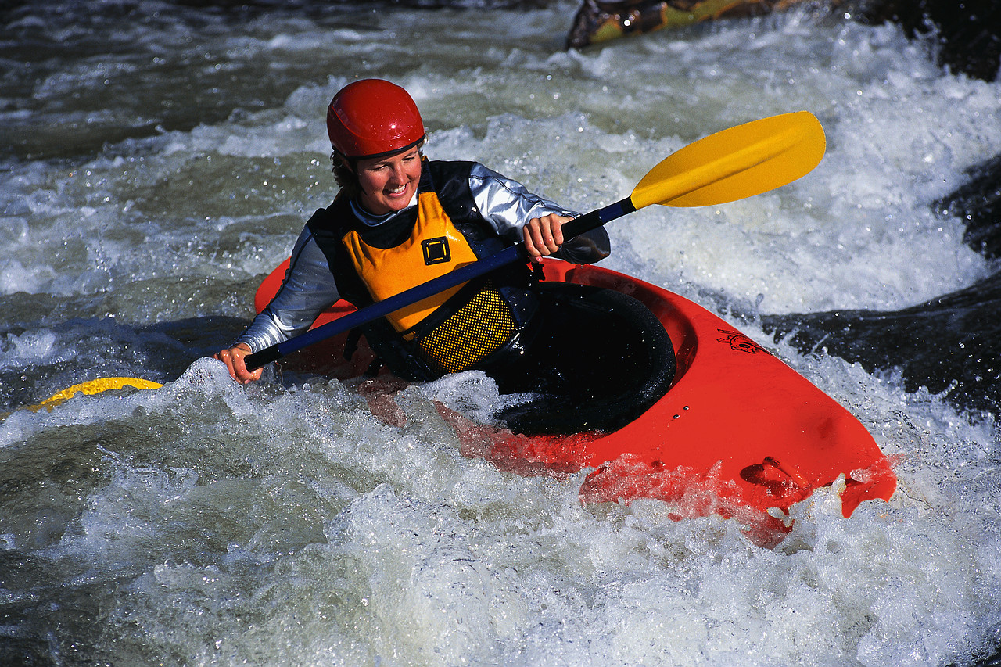 | 6  12:00  Step Aerobics  Basketball  8-9:30PM |  | 7  11-12  &  12-1  Circuit Weight  7:30 pm  Badminton | 8  11-12 Pilates  12 Step  DODGEBALL  8-9:30PM | 9  TURKEY SHOOT!!  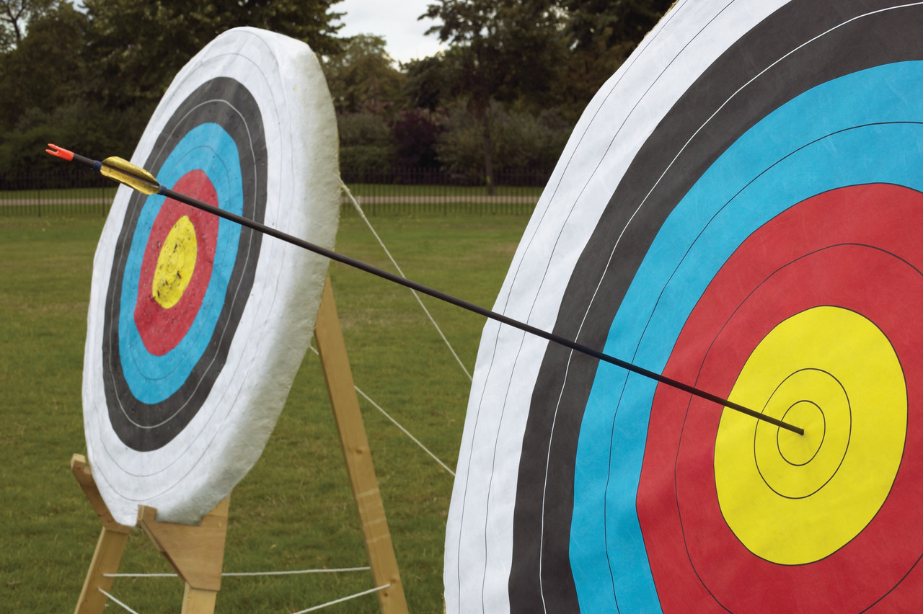  11-12& 12-1  Circuit Weight  7:30 pm  Badminton |  | 10  11-12 Pilates  12:00  Yoga | 11
12 | 13  Happy  TThanks-  Giving!  CLOSED FOR THE HOLIDAY! |  | 14  11-12  &  12-1  Circuit Weight  7:30 pm  Badminton | 15  11-12 Pilates  12:00am  Step Aerobics  Trail Walk  4:30 PM  DODGEBALL  8-9:30PM | 16  11-12  &  12-1  Circuit Weight  Noon &  3:30  Intramural Soccer  7:30 pm  Badminton |  | 17  11-12 Pilates  12:00  Yoga | 18  
19  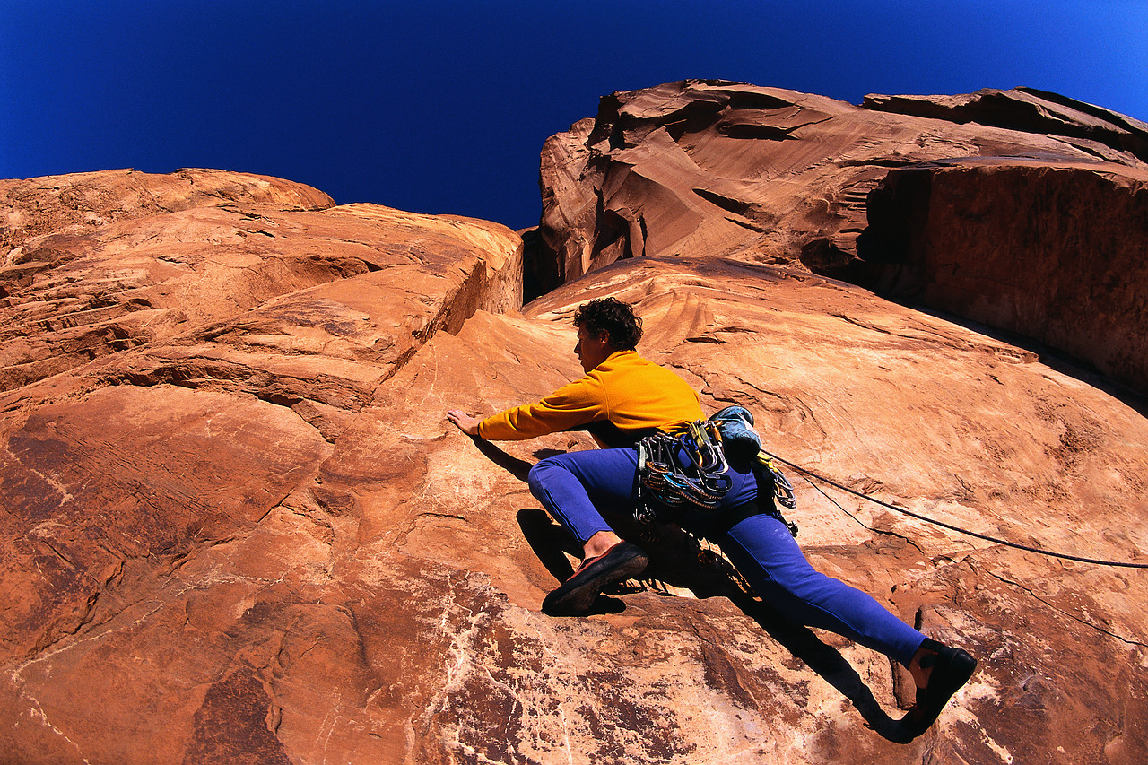 | 20  12:00  Step Aerobics  Basketball  8-9:30 PM |  | 21  11-12  &  12-1  Circuit Weight  7:30 pm  Badminton | 22  11-12 Pilates  12:00  Step  DODGEBALL  8-9:30PM | 23  11-12 +12-1  Circuit Weight  Noon + 3:30pm  Intramurals  7:30 pm  Badminton |  | 24  11-12 Pilates  12:00  Yoga | 25  
26   | 27  12:00  Step Aerobic  Running club  Basketball  8-9:30pm |  | 28  11-12 + 12-1  Circuit Weight  11:30 am  BENCH PRESS COMPETIT’N  7:30 pm  Badminton | 29  11-12 Pilates  12:00  Step  DODGEBALL  8-9:30PM | 30  11-12 +12-1  Circuit Weight  Noon + 3:30  Intramurals  7:30 pm  Badminton |  | 31  11-12  Pilates  12-1pm  Yoga | 

